High-Level Design

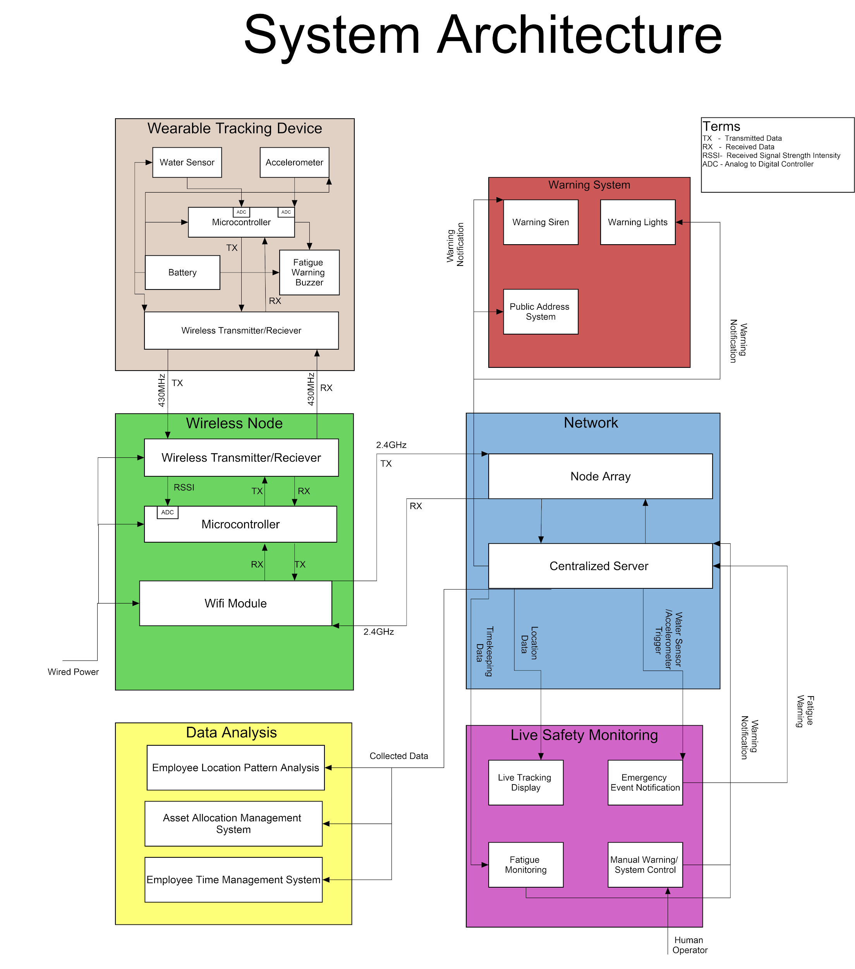

The system architecture represents a high level design of a employee and asset tracking system on an oil rig. The key design choices were informed by the lessons learnt during rapid prototyping and the market analysis. The important thing to note when viewing the system architecture is that there are man wireless nodes that make up the node array. The centralized server is located on board the oil rig. The less self explanatory parts of the diagram are explained below.

## Data Analysis

**Employee Location Pattern Analysis** - Software that uses the collected location data of oil rig workers to look for patterns in workflow and determine where performance efficiency could be increased.

**Asset Allocation Management System** - Allows for the management of equipment, tools and other resources by analysing where they are used throughout the oil rig and whether there placement could be changed to improve efficiency.

**Employee Time Management System** - Analyses the time employees are spending on particular tasks to improve efficiency.

## Live Safety Monitoring

**Live Tracking Display** - In real time the system displays the location of employees and assets

**Emergency Event Notification** - If an accelerometer or a water sensor has been triggered the system will notify management so appropriate action can be taken.

**Fatigue Monitoring** - Tracks the time employees have spent working and alerts particular workers if the system has detected fatigue and a break is required.

**Manual Warning/Control System** - Safety operator can manually trigger an emergency warning throughout the system.

## Other Considerations

The wireless nodes will communicate with each other using a 2.4GHz wifi signal as it has a better range than 5GHz. The wireless nodes will likely need to be connected to mains power form the rig as the power requirements of the wifi module will be too high to make portable power feasible in the long term. Wireless nodes were used over wired nodes for flexibility. The wireless nodes only require a connection to power and not the routing of data cables from each node to the server.

Tracking devices will only use a less powerful 430MHz signal and will be able to be run of portable battery power. The battery will be rechargeable and can be charged when the tracking device is not in use.